PHASE 3: Consumer Development

Step 3.1: Live Consumer (Real-time Stats)
- Create: D:\kafka-project\consumers\consumer_live.py
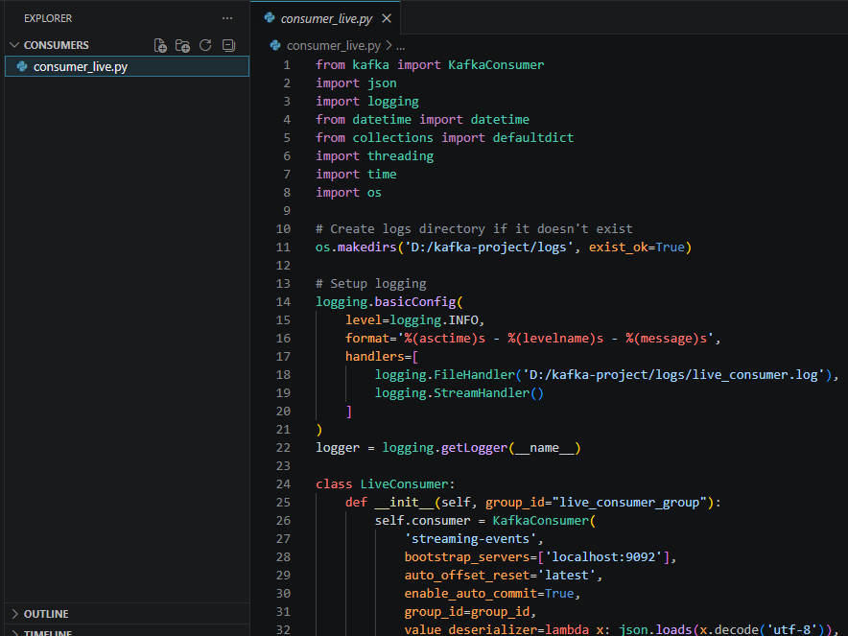
Step 3.2: Storage Consumer (Database)
- Create: D:\kafka-project\consumers\consumer_storage.py
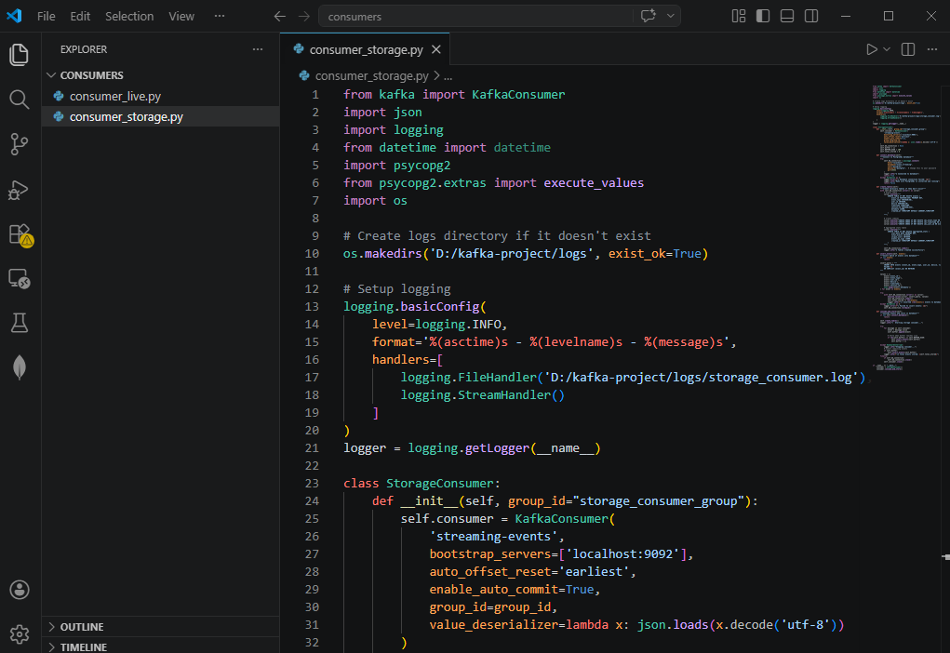
IF ANY ERROR RUN THIS 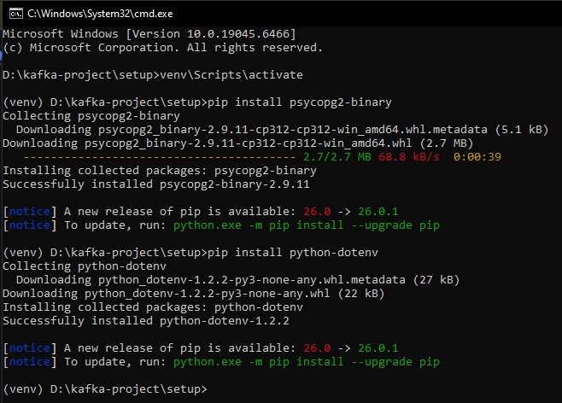

Run the producer and consumer
- Start Kafka first:
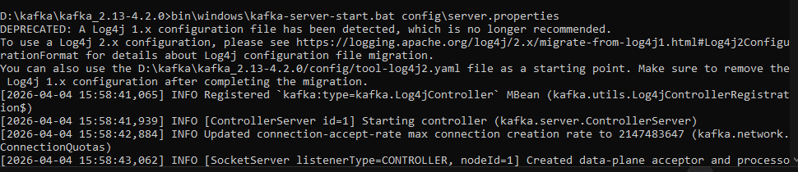
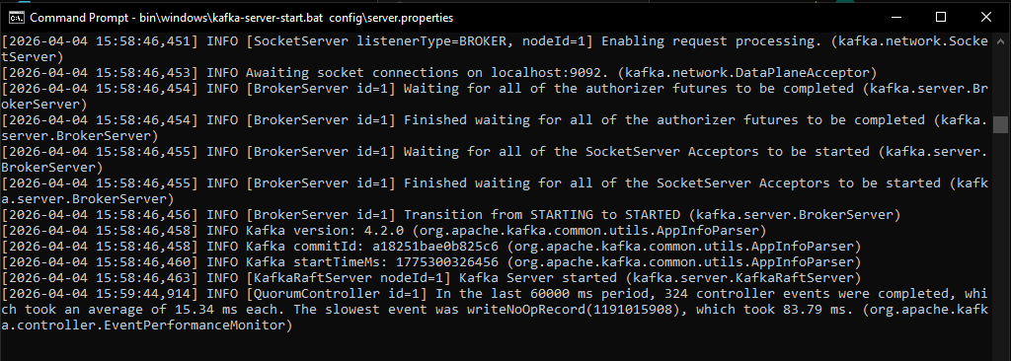
- Run the producer
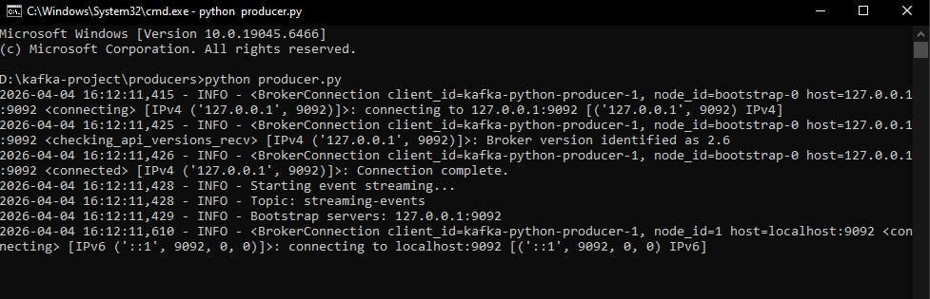
- Run the live consumer
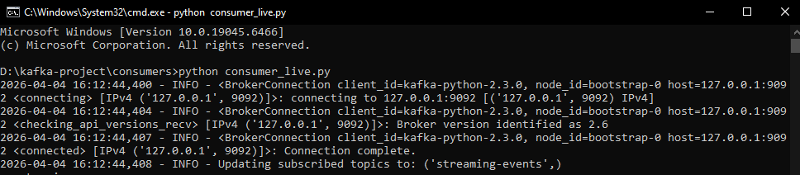
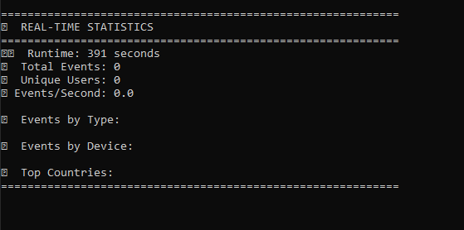
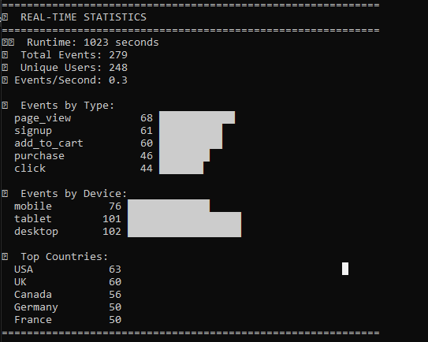

- Run the storage consumer
Run only when the database is connected. Otherwise it is ok till phase 3. We are going to make database in phase 4. Then do this running steps to check if it working or not
IF ANY ERROR RUN THIS
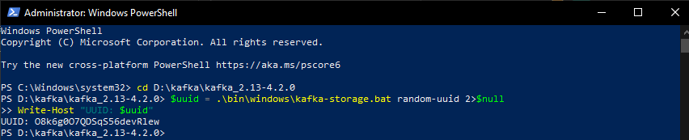
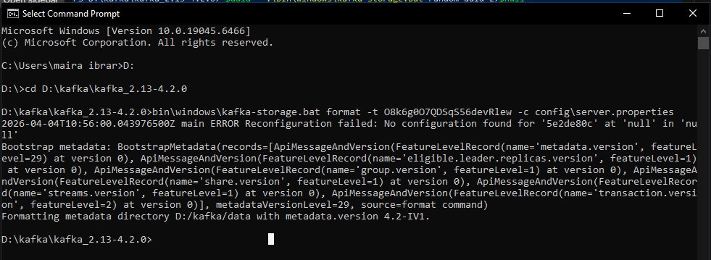

UUID: O8k6g0O7QDSqS56devRlew (use your own)

